**IBM assignment-4**

**Team ID:PNT2022TMID40702**

**4.write code and connections in wowki for ultrasonic sensor.whenever distance is less than 100cm send “alert” to ibm cloud and display in device recent events.upload document with wowki share link and images of ibm cloud.**

#include <WiFi.h>

#include <PubSubClient.h>

void callback(char* subscribetopic,byte* payload, unsigned int payloadLength); #define ORG "fdd82r"

#define DEVICE_TYPE "Pi"

#define DEVICE_ID "123"

#define TOKEN "12345678"

String data3;

char server[]= ORG ".messaging.internetofthings.ibmcloud.com"; char publishTopic[]="iot-2/evt/distance/fmt/json";

char subscribeTopic[]="iot-2/cmd/test/fmt/String";

char authMethod[]="use-token-auth";

char token[]=TOKEN;

char clientID[]="d:"ORG":"DEVICE_TYPE":"DEVICE_ID;

WiFiClient wifiClient;

PubSubClient client(server,1883,callback,wifiClient);

#define ECHO_PIN 2

#define TRIG_PIN 4

#define led 5

void setup() {

// put your setup code here, to run once:

**Serial**.begin(115200);

pinMode(led, OUTPUT);

pinMode(TRIG_PIN, OUTPUT);

pinMode(ECHO_PIN, INPUT);

wificonnect();

mqttconnect();

}

float readDistanceCM() {

digitalWrite(TRIG_PIN, LOW);

delayMicroseconds(2);

digitalWrite(TRIG_PIN, HIGH);

delayMicroseconds(10);

digitalWrite(TRIG_PIN, LOW);

int duration=random(1,200);

//Serial.println(duration);

//duration = pulseIn(ECHO_PIN, HIGH);

return duration ;

//Serial.println(duration);

}

void loop() {

float distance = readDistanceCM();

//Serial.println(distance);

bool isNearby = distance < 100;

digitalWrite(led, isNearby);

**Serial**.print("Measured distance: ");

**Serial**.println(distance);

if(distance<100){

PublishData2(distance);

}else{

PublishData1(distance);

}

//PublishData(distance);

delay(1000);

if(!client.loop()){

mqttconnect();

}

//delay(2000);

}

void PublishData1(float dist){

mqttconnect();

String payload= "{\"distance\":";

payload += dist;

payload+="}";

**Serial**.print("Sending payload:");

**Serial**.println(payload);

if(client.publish(publishTopic,(char*)payload.c_str())){ **Serial**.println("publish ok");

} else{

**Serial**.println("publish failed");

}

}

void PublishData2(float dist){

mqttconnect();

String payload= "{\"ALERT\":";

payload += dist;

payload+="}";

**Serial**.print("Sending payload:");

**Serial**.println(payload);

if(client.publish(publishTopic,(char*)payload.c_str())){ **Serial**.println("publish ok");

} else{

**Serial**.println("publish failed");

}

}

void mqttconnect(){

if(!client.connected()){

**Serial**.print("Reconnecting to ");

**Serial**.println(server);

while(!!!client.connect(clientID, authMethod, token)){ **Serial**.print(".");

delay(500);

}

initManagedDevice();

**Serial**.println();

}

}

void wificonnect(){

**Serial**.println();

**Serial**.print("Connecting to");

WiFi.begin("Wokwi-GUEST","",6);

while(WiFi.status()!=WL_CONNECTED){

delay(500);

**Serial**.print(".");

}

**Serial**.println("");

**Serial**.println("WIFI CONNECTED");

**Serial**.println("IP address:");

**Serial**.println(WiFi.localIP());

}

void initManagedDevice(){

if(client.subscribe(subscribeTopic)){

**Serial**.println((subscribeTopic));

**Serial**.println("subscribe to cmd ok");

}else{

**Serial**.println("subscribe to cmd failed");

}

}

void callback(char* subscribeTopic, byte* payload, unsigned int payloadLength){

**Serial**.print("callback invoked for topic:");

**Serial**.println(subscribeTopic);

for(int i=0; i<payloadLength; i++){

data3 += (char)payload[i];

}

**Serial**.println("data:"+ data3);

if(data3=="lighton"){

**Serial**.println(data3);

digitalWrite(led,HIGH);

}else{

**Serial**.println(data3);

digitalWrite(led,LOW);

}

data3="";

}

**WOKWI project link**

https://wokwi.com/projects/346327942785139284

Alert Case:

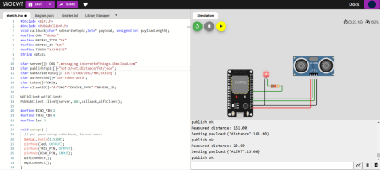

Normal Case:

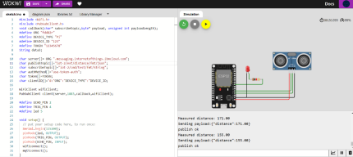

Cloud storage:

